**Assignment-3 Sequence diagram of Tetris game**

**Description:**

A sequence diagram is that depicts a particular scenario of a use case, the events that external actors generate, their order and possible inter-system events.

The below sequence diagram has instances such as clock, player, game control, game board, tile and information panel.

The clock cycle begins and the tile starts falling from the top.

First the control enters into the first loop and performs following functions:

* If the left arrow key is pressed by the player then the tile is moved left and if the next row is empty then the tile is moved a row down else the control is moved out of the first major loop and comes out of this loop.
* Else if the down arrow key is pressed then the tile is dropped smoothly and the score is incremented by 5 and comes out of this loop.
* Else if up arrow key is pressed then the tile is rotated towards right and if the next row is empty then the tile is moved a row down else the control is moved out of the first major loop and comes out of this loop.
* Else if space key is pressed then the tile is dropped hardly and the score is incremented by 20 and comes out of this loop.
* Else if Z key is pressed then the tile is rotated towards left and if the next row is empty then the tile is moved a row down else the control is moved out of the first major loop and comes out of this loop.
* Else if the right arrow key is pressed then the tile is moved right and if the next row is empty then the tile is moved a row down else the control is moved out of the first major loop and comes out of this loop.
* Else if Esc key is pressed then the game is paused and comes out of this loop.

Now the control enters into second loop and performs following functions:

* If the tile is dropped and
  + If the dropped tile makes a row filled completely then increments the score by 10, lines count by 1 and clear that line and comes out of this loop.
  + Else if the tile is dropped on the top row of the board then display on the game board that the game is over and the final score and comes out of this loop. ➢ Else if the tile is not dropped then control should execute first loop.

This clock cycle ends at this point and the next clock cycle starts.

**Diagram:**

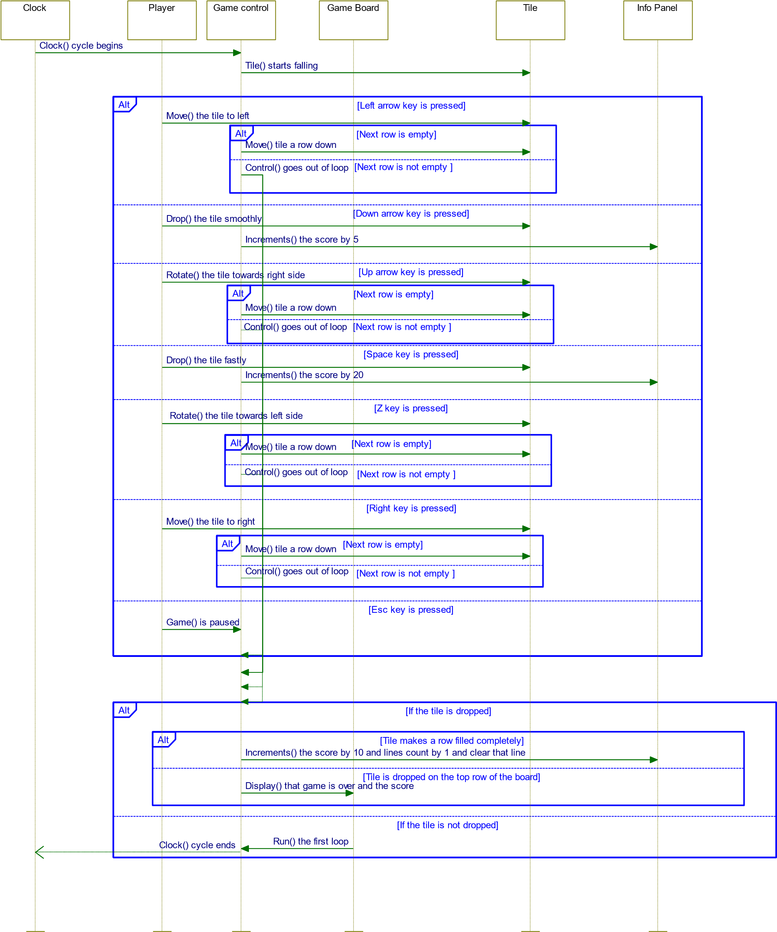

# State diagram for Tetris game

NewGame



Start the game



Game ends or paused

GameBoard



start game/quit game

If player selects new game]/New game is started

[

GamePaused



game paused and data is saved



game resumed

[

When pause option is selected]/Game is paused

GameOver



game ends and display score



Quit game or start a new game

When player looses the game]/Game is ended

[

When player selects quit optn]/Game quits

[

[

When player selects quit option]/Game quits

GameResumed



Game resumed



Game ends or paused

[

When resume optn is selected]/Game is resumed

[

When player looses the game]/Game is ended

[

When pause optn is selected]/Game is paused

**Description:**

* This state diagram has 5 states such as NewGame, GameBoard, GamePaused, GameResumed,GameOver.

* Transition from GameBoard to NewGame will occur when player selects new game.
* Transition from NewGame to GamePaused , when pause option is selected.
* Transition from GamePaused to GameResumed and GameResumed to GamePaused will occur when resume and pause options are selected.
* Transiton from NewGame, GameResumed to GameOver will occur when player loses the game.
* States GameBoard and GameOver terminate when player quits from game.

